**Introduction**  
**B Tree** => **Balanced Multiway Search Tree (Bayer and McCreight in 1972)**  
**Node can have more than 1 key  
Node can have more than 2 children**  
* **B Tree is best suited for External Searching - when data is to be retrieved from secondary storage**.  
* **Systems that read and write large blocks of data from external storage generally use B Trees**.  
* **Commonly used in Databases and File Systems**.  
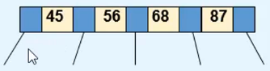  
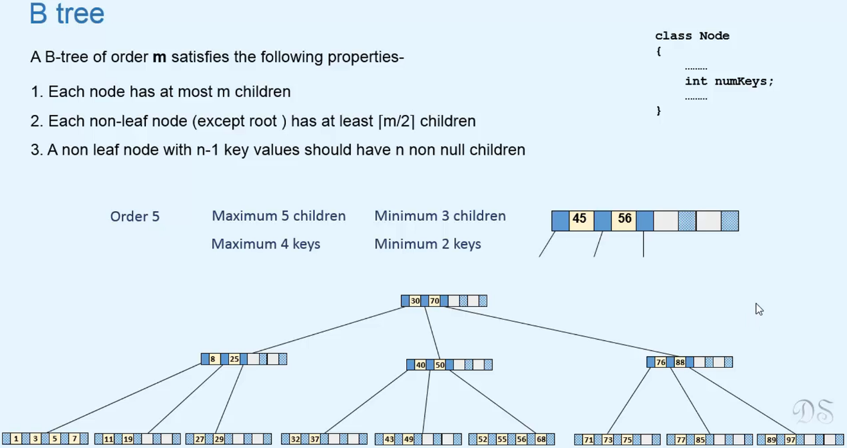  
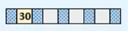 => Root as a leaf node, at least 1 key, no children.  
* **Root is the only node that can have only 1 key**.  
* **B Tree is a Balanced Tree due to the #5 property that all leaf nodes are at the same level**.  
* **B Tree is a Search Tree so the data has to be stored in sorted order - Ascending order**.  
* **Keys in non-leaf nodes act as separator values**.  
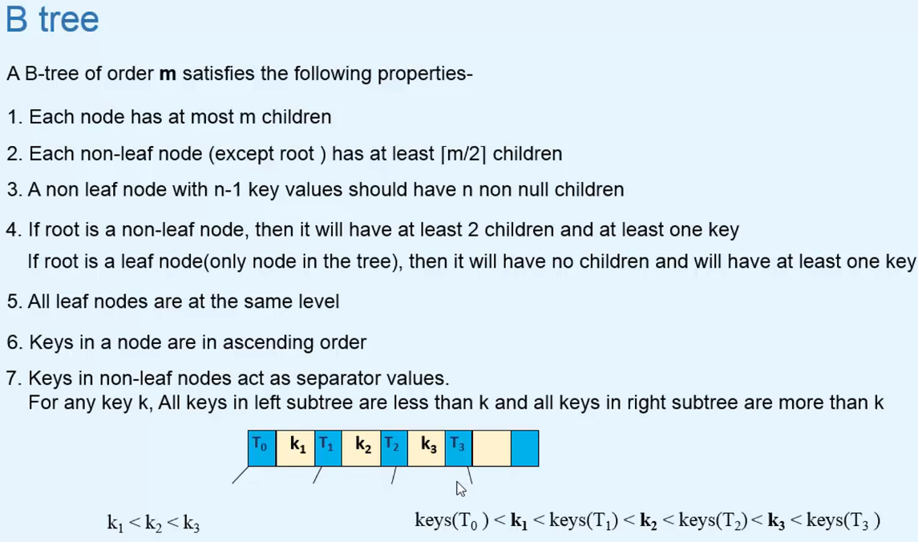  
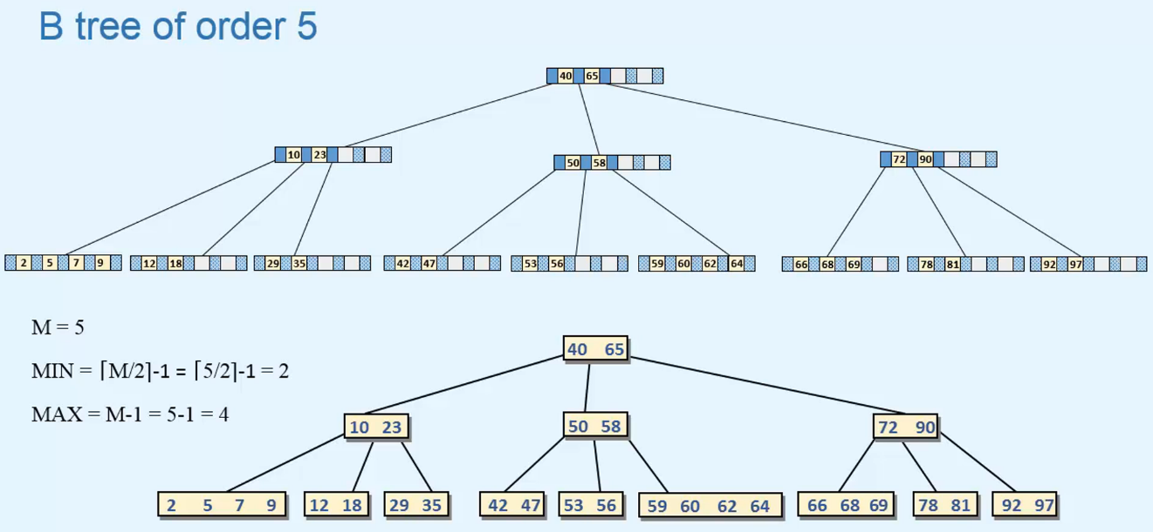  
=> **This restriction of MIN KEYS ensures that each node is at least 50% full so there’s less waste of storage space**.  
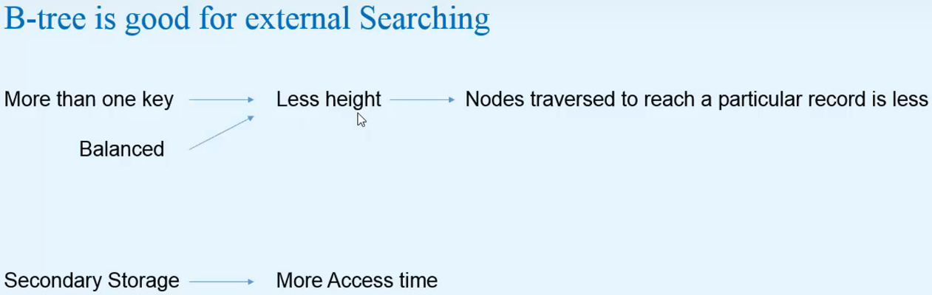  
=> **To optimize searching on Secondary Storage, the number of accesses should be less**.  
=> **This can be done by using a Tree which has less height**.  
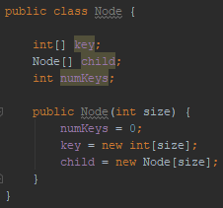 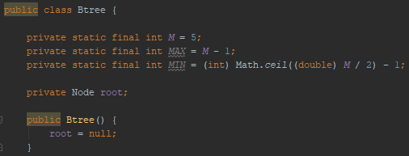  
* **We’ll store the keys from index 1 onwards, so for m = 5 it will be int[5] but we’ll only use 4 keys max**.  
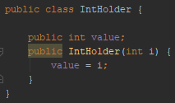 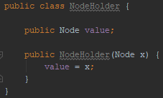

**Inorder Traversal**  
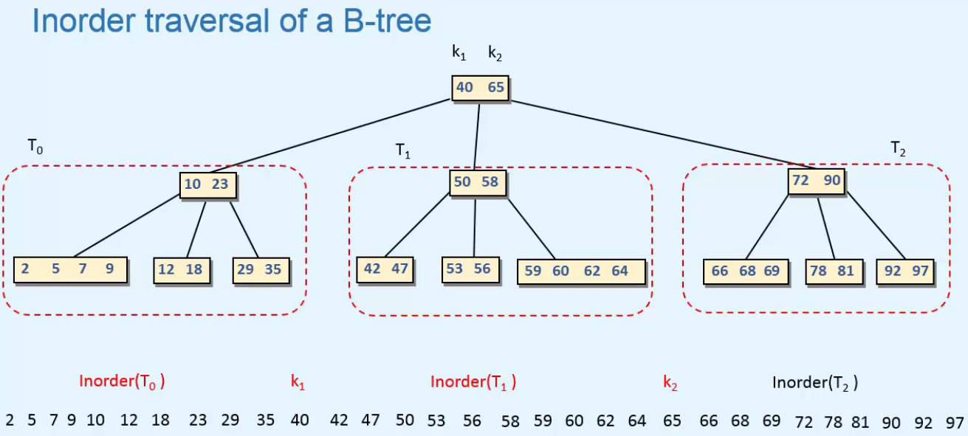  
=> **Prints all the keys in an ascending order**.  
  
=> So first Inorder of 0th subtree is printed, then 1st key is printed, then Inorder of 1st subtree is printed and then the 2nd key is printed.  
=> Inorder of 0th subtree then 1st key  
=> Inorder of 1st subtree then 2nd key  
* **The loop stops when i < p.numKeys so if there are 4 keys in this node, then this loop will stop when i = 4. In that case, we just want to print the Inorder of 4th subtree which is the right-most subtree of the node**.   
* **There’s no key after the 4th subtree**.  
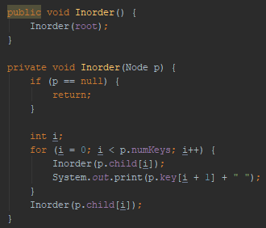 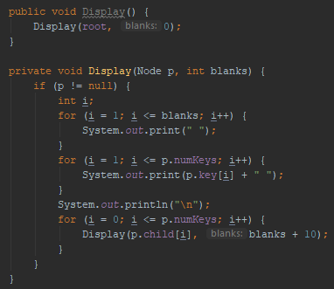

**Searching**  
* Similar to searching in a BST.  
* In a BST, we start searching from the root node and then we go left or right.  
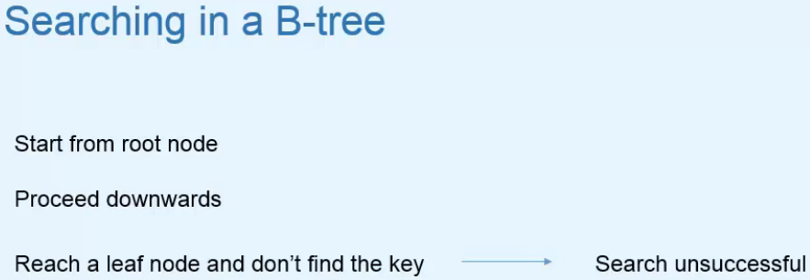  
=> **If we find the key in any node, then the search is successful**.  
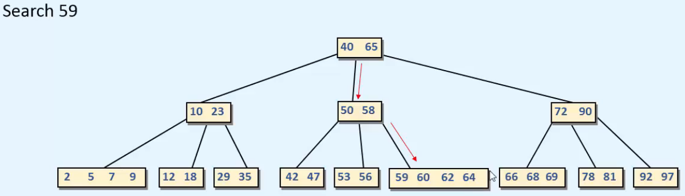  
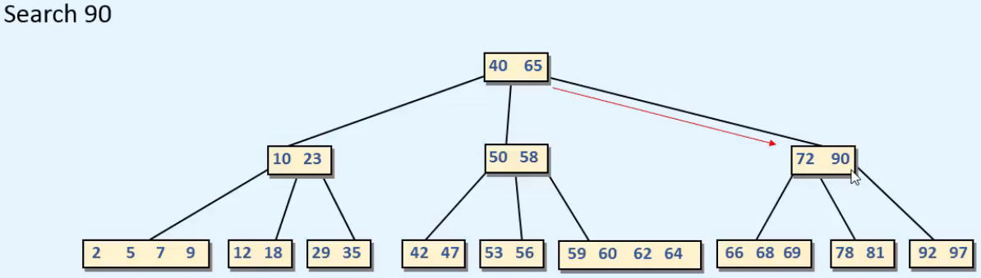  
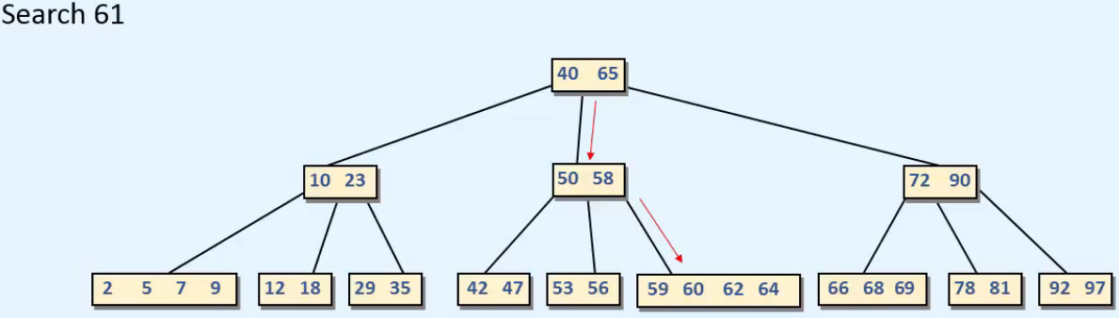  
=> **Search unsuccessful**.

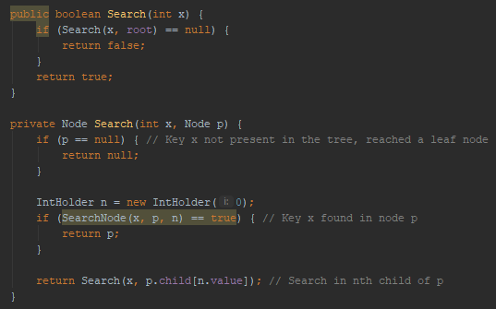  
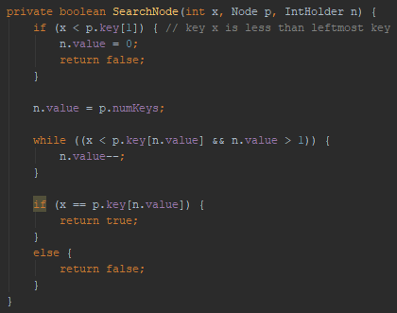  
=> **The SearchNode() sets the value of IntHolder n** and we use that value in Search(x, p.child[n.value]), basically **we’re simulating pass by reference for this 3rd argument**.   
* If x is present in node p, we return p.  
* If x is NOT present in node p, then we have to search in a subtree of node p.  
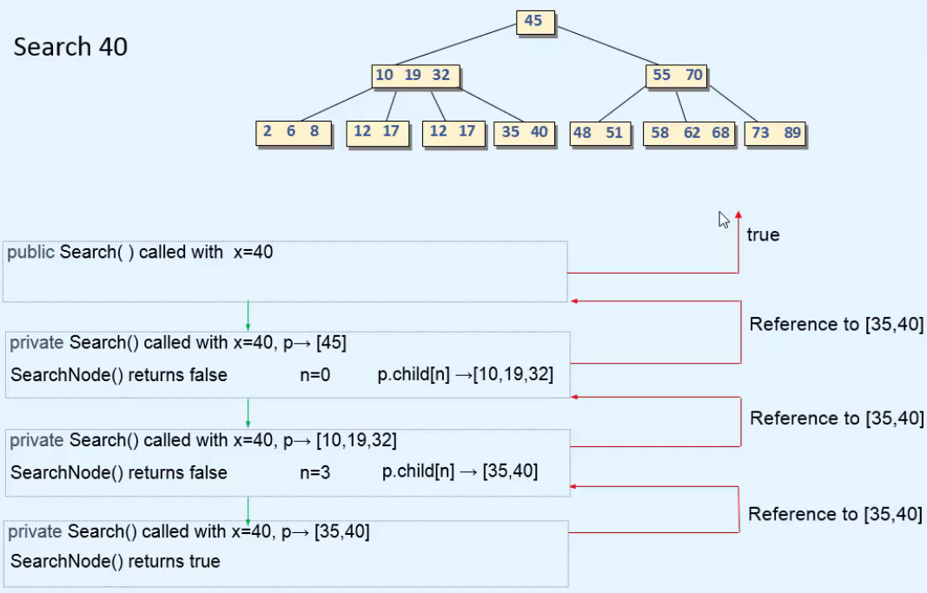  
* **We’re using n instead of n.value to make it simple**.

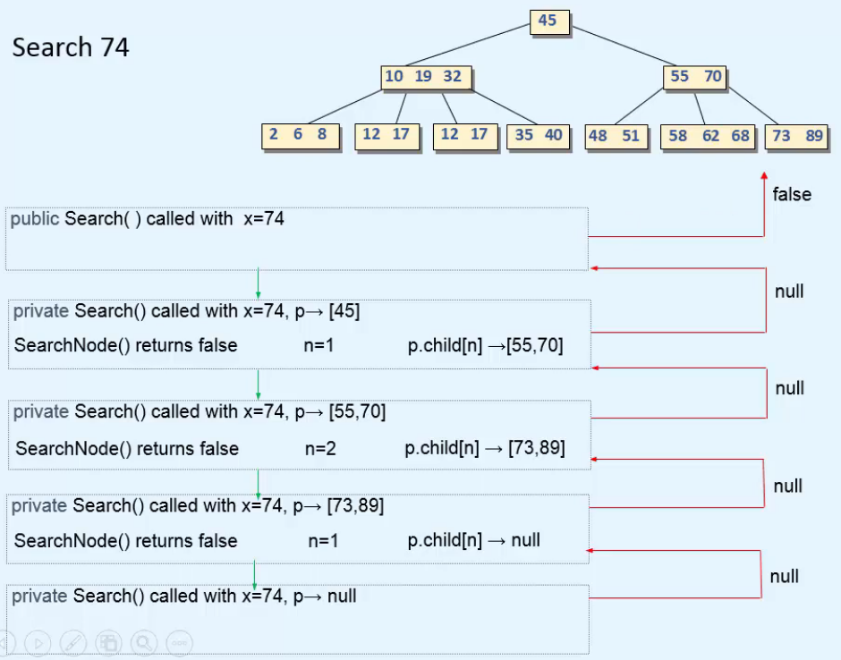

**Insertion**  
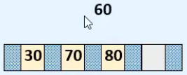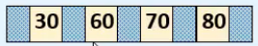  
* **If the new key is > all the keys in the node, there will be no shifting**.  
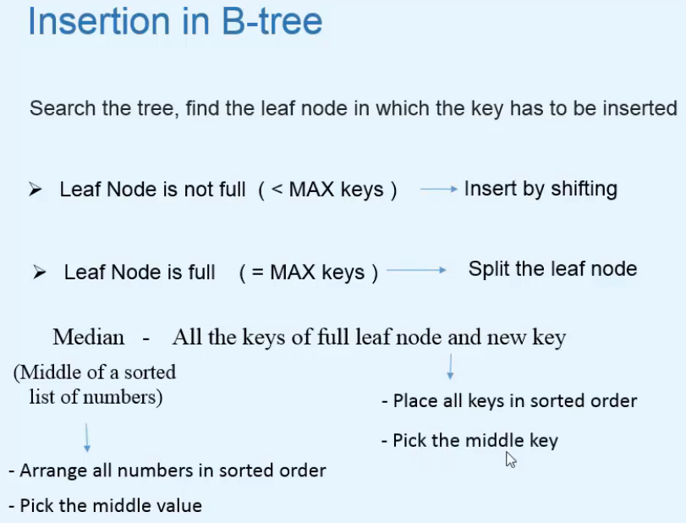 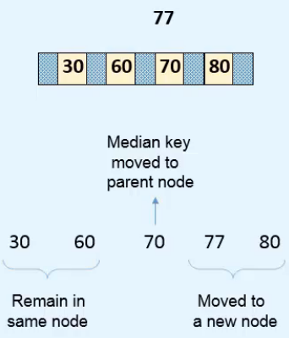

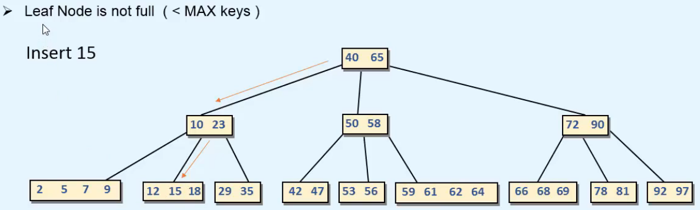  
* **Now let’s see a full node insertion**.  
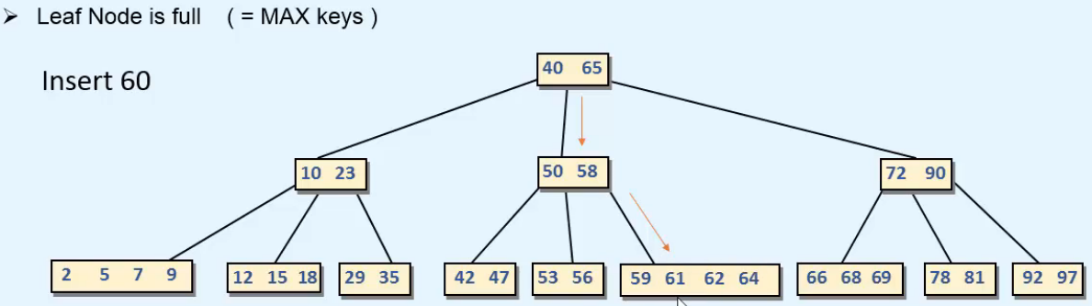  
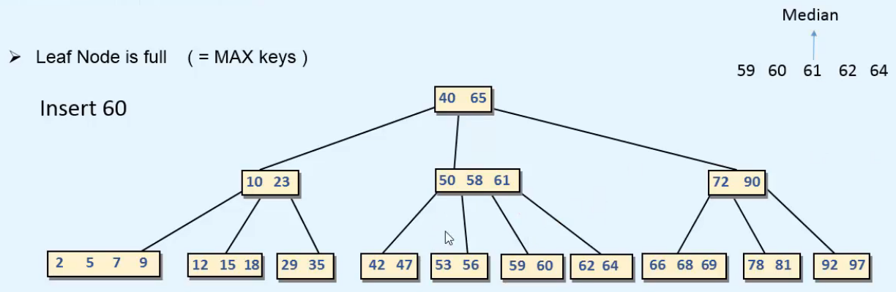  
* **If the parent node is full**:  
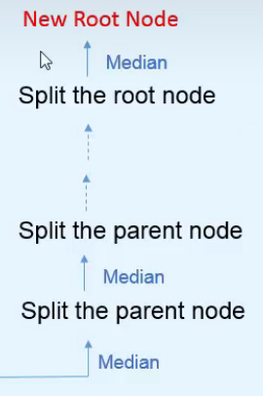  
=> **If we split the root, the median will go in the root and the height of the tree will increase by +1**.  
* **Now we can see that why there’s no restriction of MIN keys for the root node - root node is special, it can exist with only 1 key as well**.

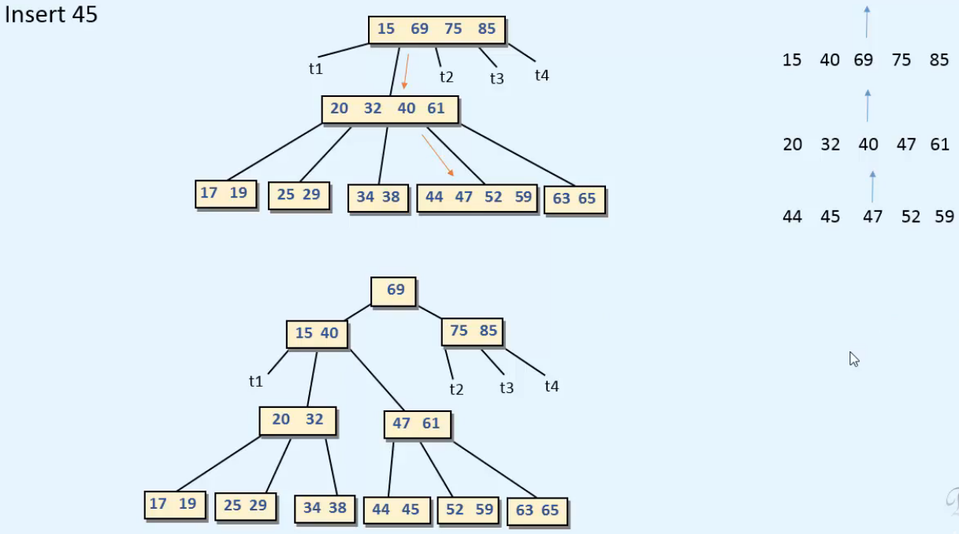

* Let’s see the process of creating a B Tree:  
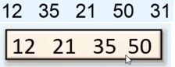 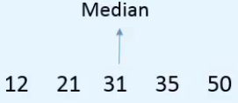 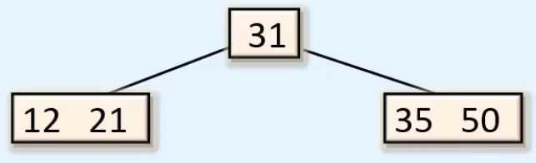

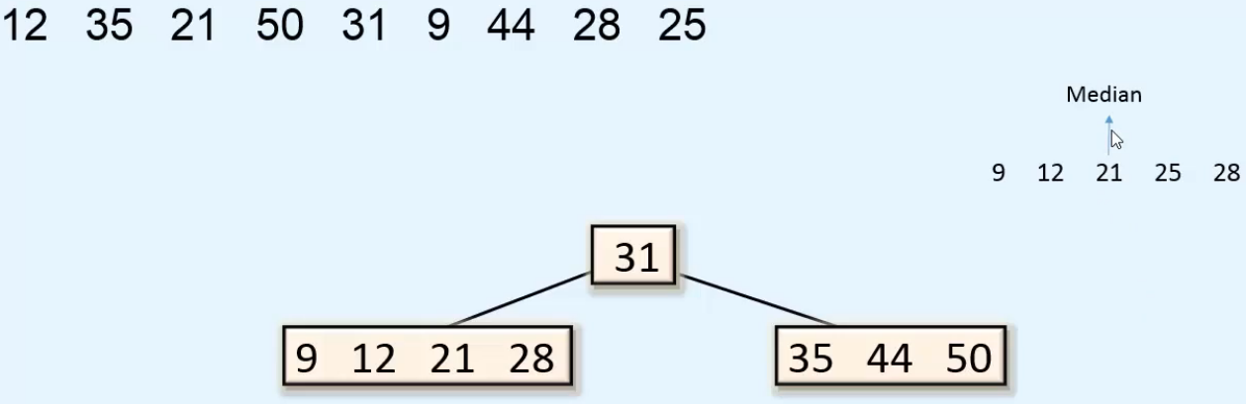

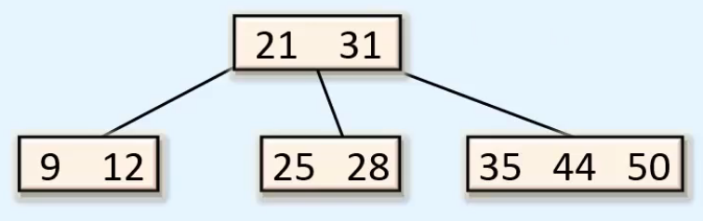

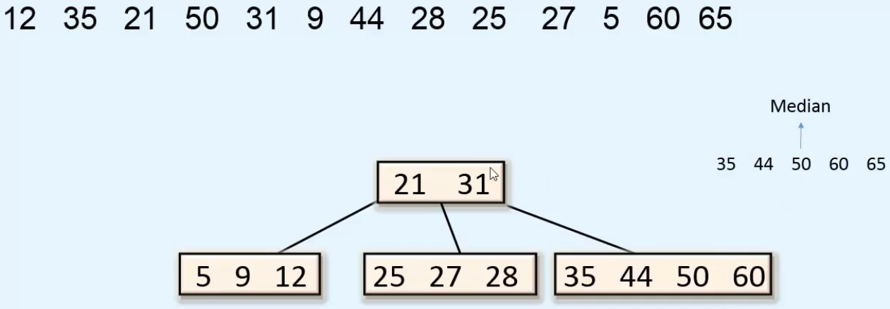

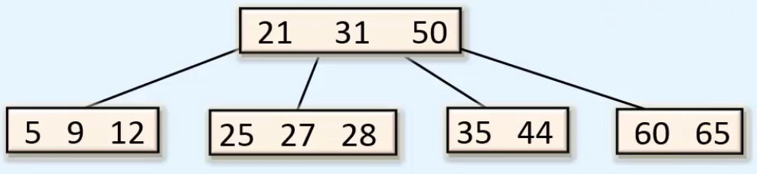

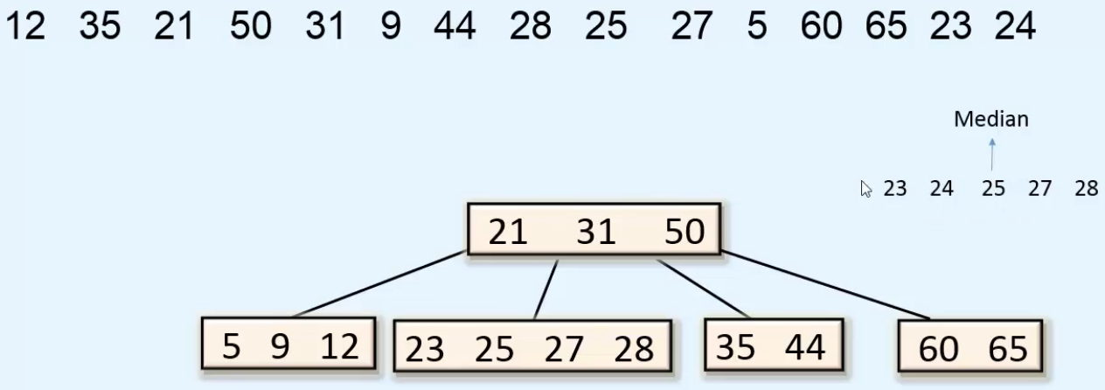

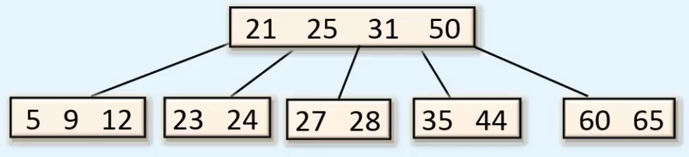

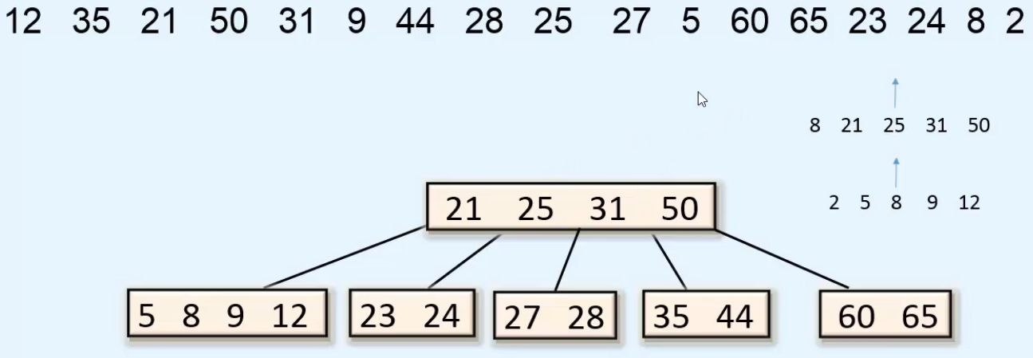

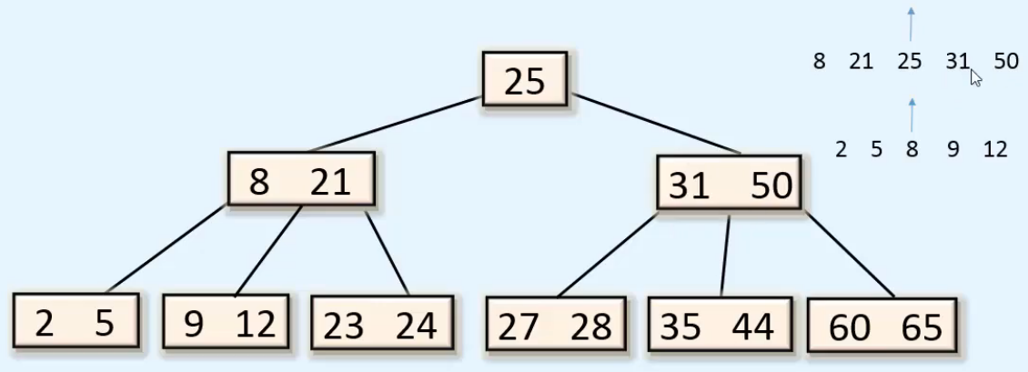

**Implementation of Insertion - 1**  
**x** => **the key to be inserted**  
**root** => **root of the tree  
iKey** => **the median key after splitting the root node, int by reference  
iKeyRchild** => **node by reference**  
* We’ll go down the tree starting from the root node and we’ll find the leaf node where the new key has to be inserted.  
* We know that in the unwinding phase, we’ll move up the tree on the path of insertion.  
=> We’ll pass through each parent node up to the root node.  
=> **So the work of splitting will be done in the unwinding phase**.  
* **The flag call will be executed in the unwinding phase.**  
* The **Insert(x, p.child[n.value], iKey, iKeyRchild)** => we have to insert in the nth subtree of node p.  
=> The **SearchNode(x, p, n)** => gives us the value of n ^  
* The InsertByShift(p, n.value, iKey.value, iKeyRchild) => we’ll insert the key iKey.value in node p after position n.value.  
* The Split(p, n.value, iKey, iKeyRchild) => will set iKey to the median key that has to go up and it will change iKeyRchild accordingly.  
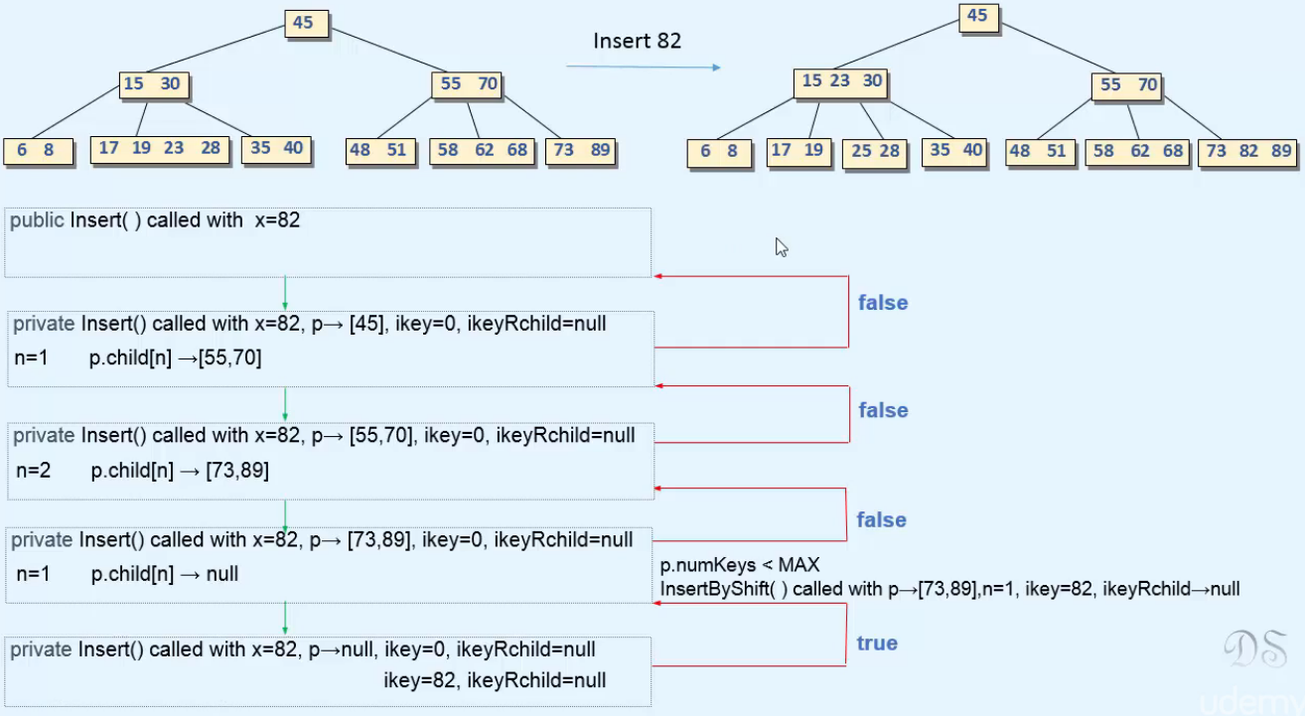  
**^ mistake in the right tree on the picture - the result tree is shown after inserting 25**  
* To keep it simple, we use n instead of n.value and iKey instead of iKey.value and iKeyRchild instead of iKeyRchild.value.  
* **For Insert 82, taller is false when we unwind**.

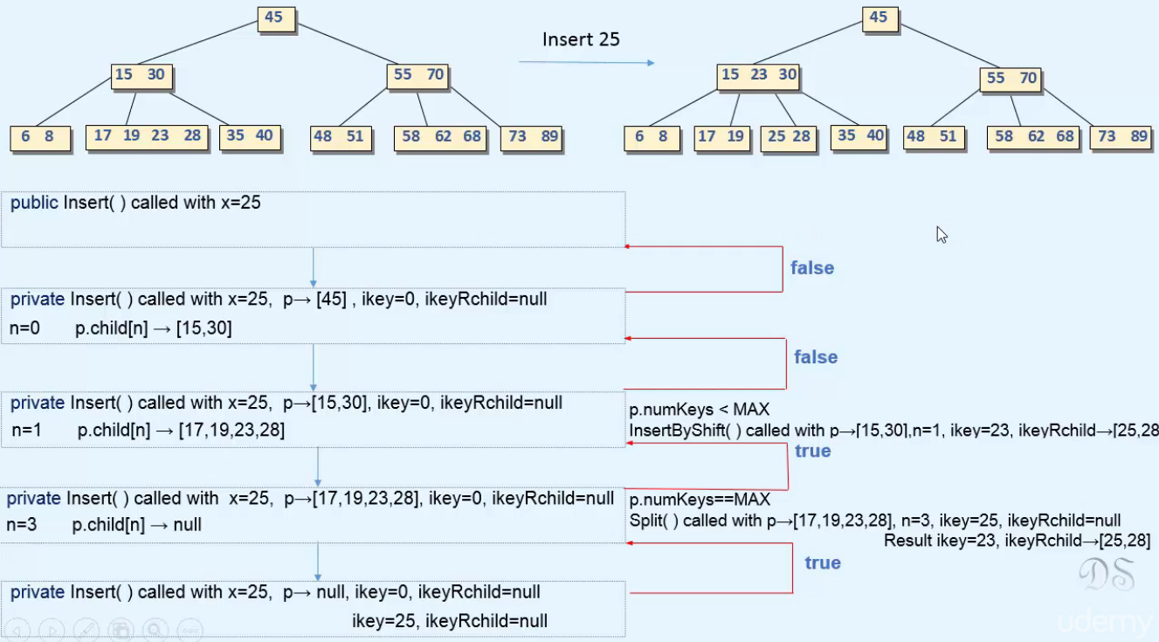

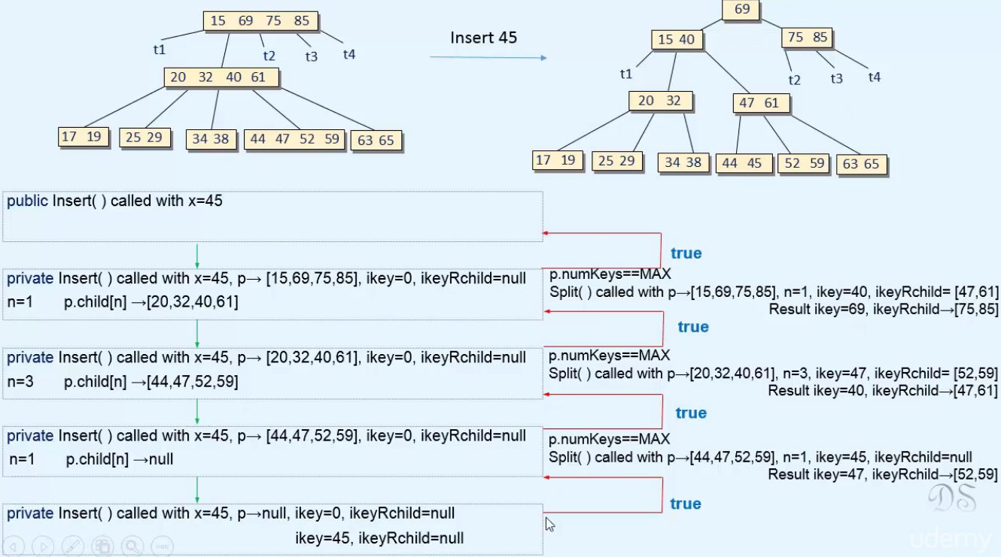  
=> **taller = true so we create a new root node and 69 will be inserted**.

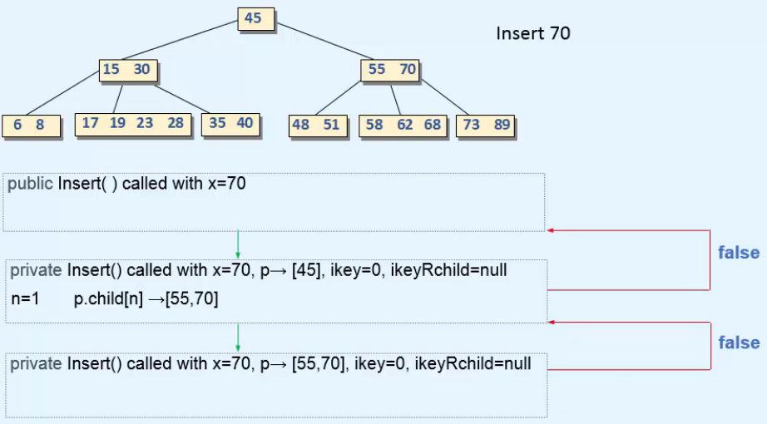  
* **Code**:  
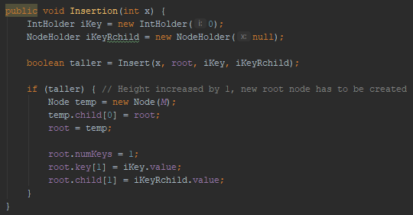

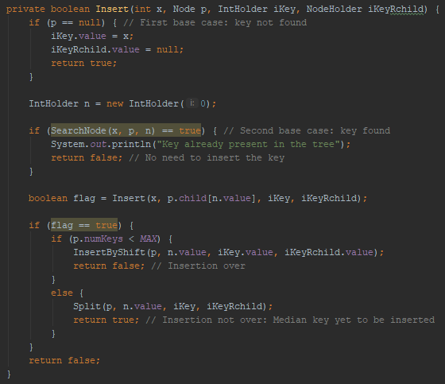

**Implementation of Insertion - 2**  
* **We’re shifting the keys and children to right and then placing iKey and iKeyRchild and incrementing numKeys**.  
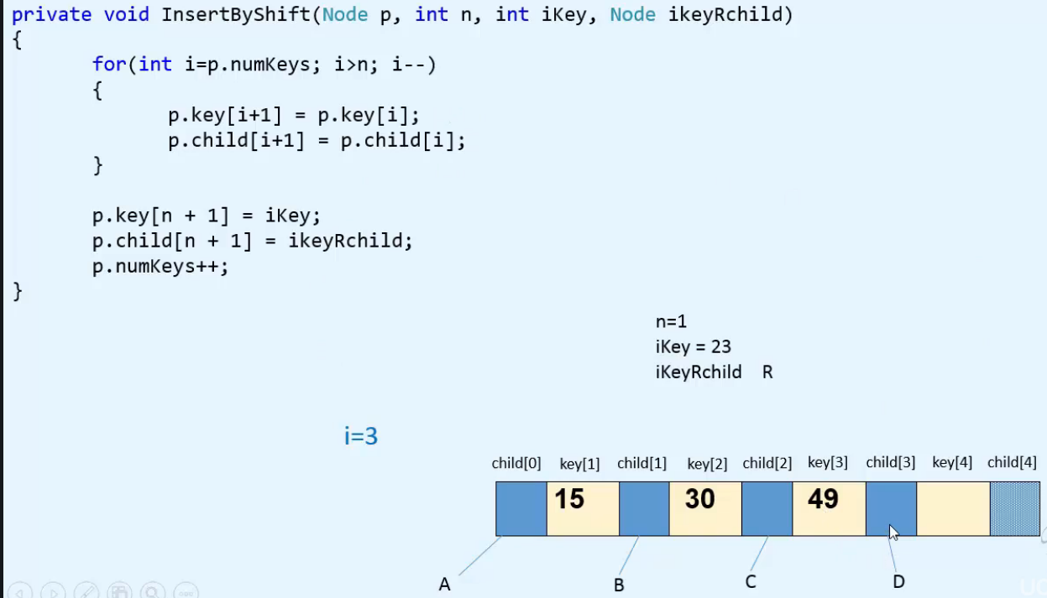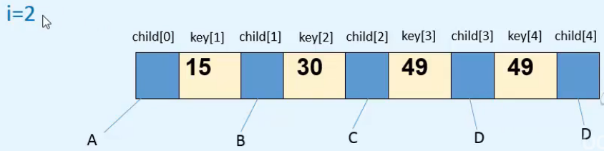  
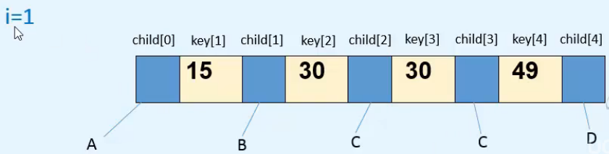  
* Now i == n, so the FOR loop terminates.  
* We place iKey and iKeyRchild to n+1 => 2.  
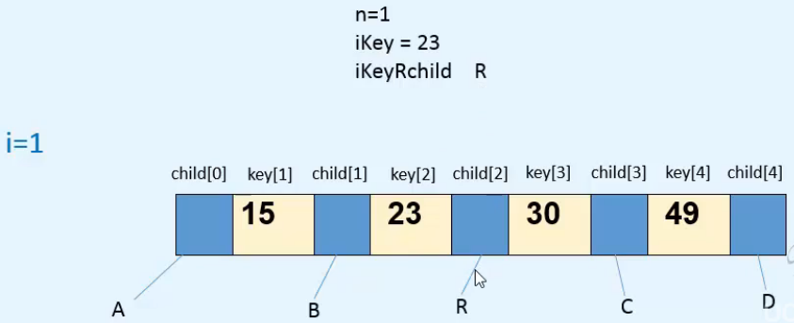

* **In the Split, we first need to find the median key from among the node’s keys and the new key**.  
* We can have 2 cases:  
**1) => New key is largest of all the keys**  
**2) => New key belong somewhere inbetween the node’s keys**  
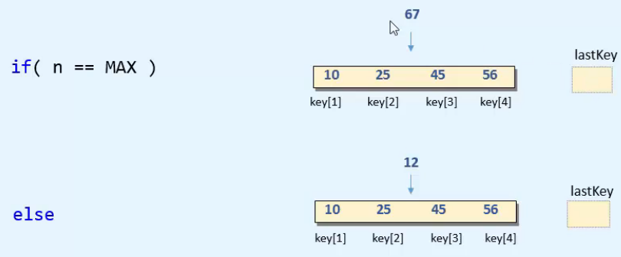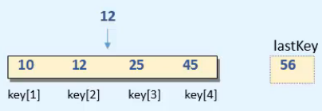  
* **ELSE => we place the largest key to lastKey and shift the nodes larger than 12 to the right**.  
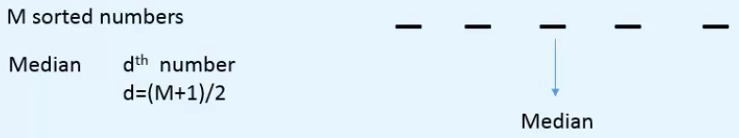  
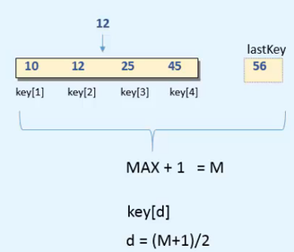

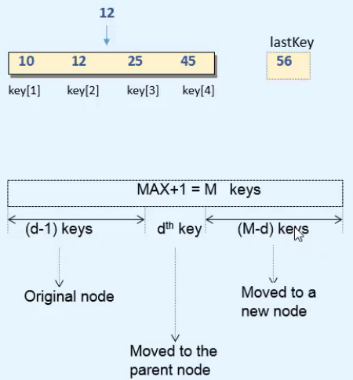  
* **Code**:  
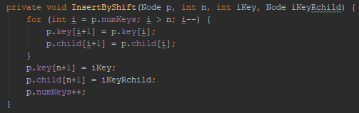  
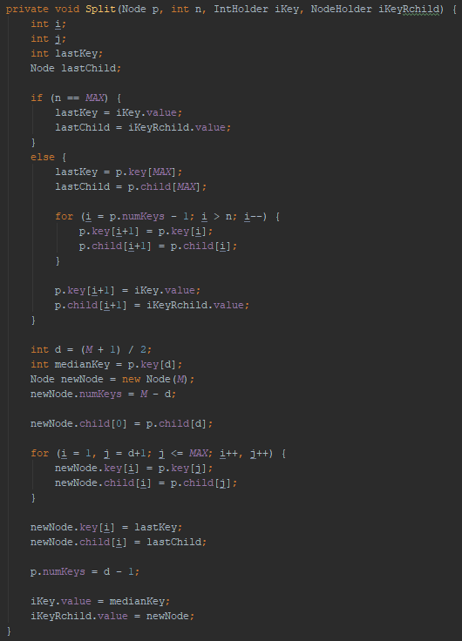

**Deletion**  
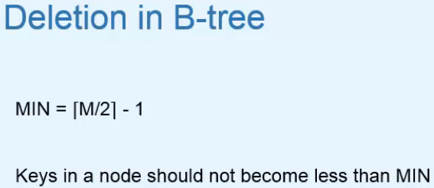=> **If they do become less than MIN, we have to do some extra work**.  
=> **Successor of the key will definitely be in a Leaf Node so it reduces to Deletion from Leaf Node**.  
  
=> **If we want to delete 30, we shift 70 and 80 to the left and then p.numKeys--**  
=> **If we want to delete 80, we just p.numKeys--**  
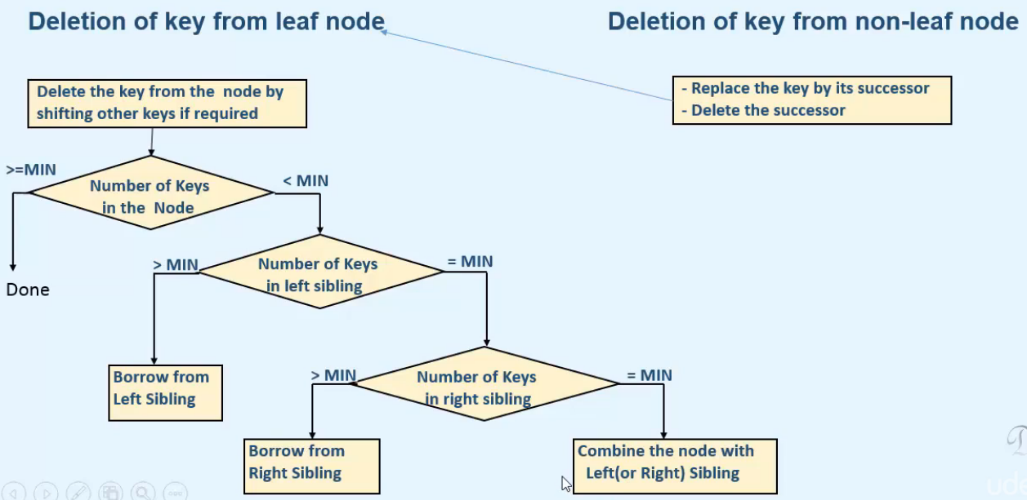  
=> **If the numKeys is < MIN**, we try to **borrow a key from one of the sibling nodes**.  
=> First look at the numKeys in the left sibling, then in the right sibling.  
* **if right numKeys = MIN or there’s no right sibling, then combine the node with one if its siblings**.

**Examples of Deletion from Leaf Node**  
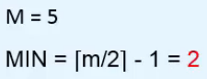

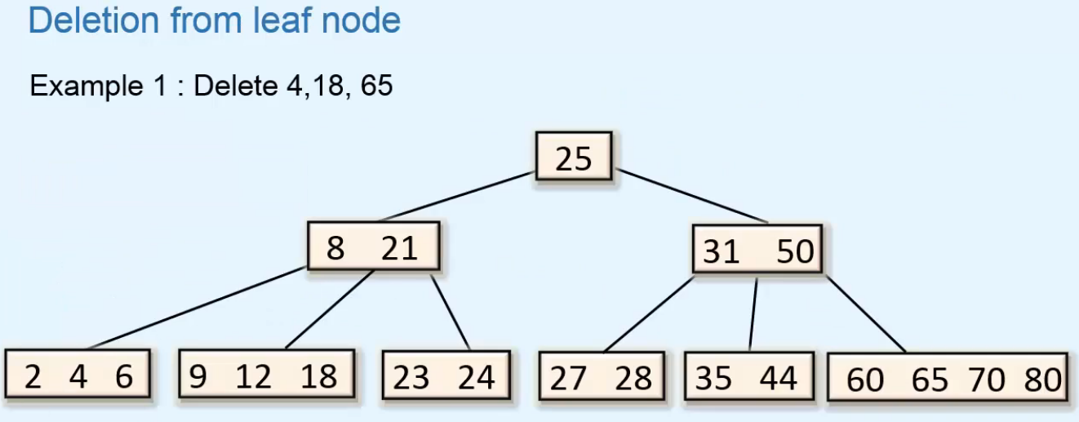

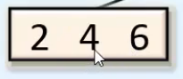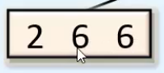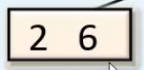

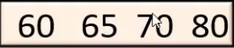 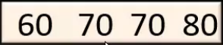 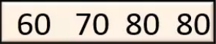   
=> **We shift the keys to the left if needed and we decrement the numKeys**.  
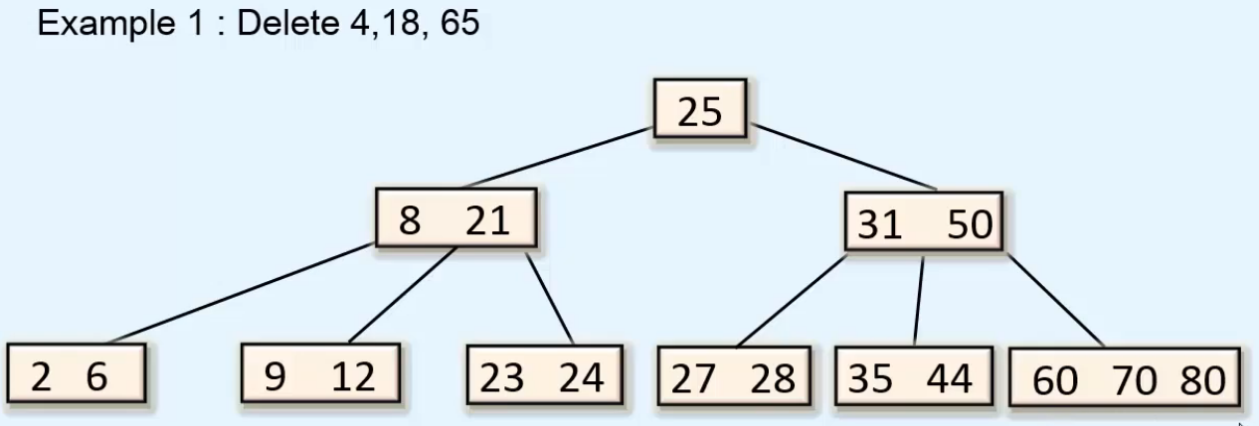

* **Another example (different tree but similar)**  
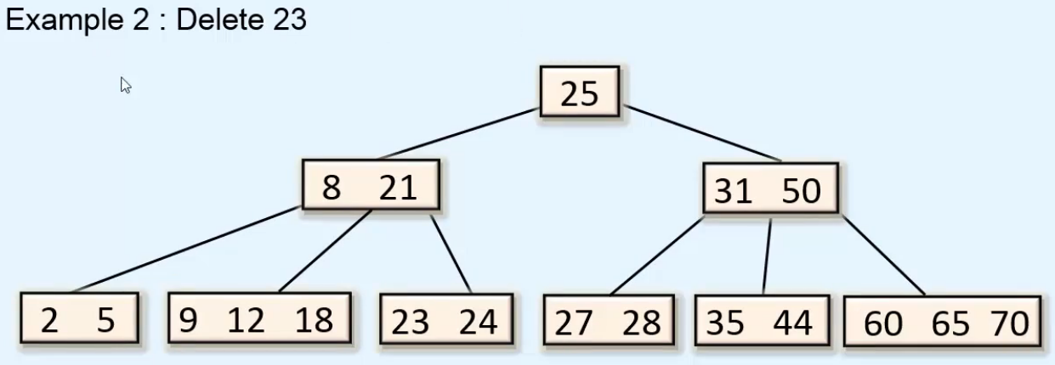  
=> **We shift 24 to the left and decrement numKeys for this node**.  
=> **numKeys < MIN (<2)**  
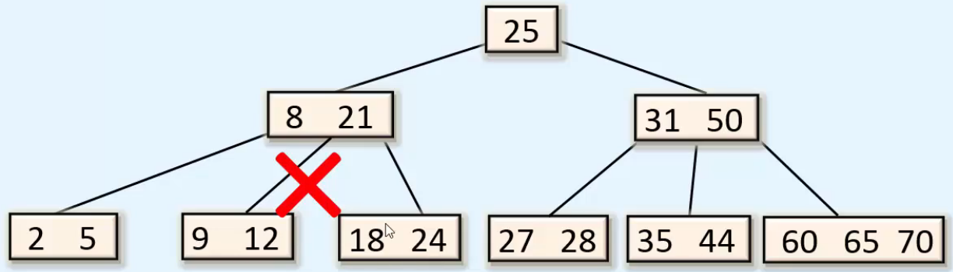  
=> **We can’t take 18 since the keys in the right subtree wouldn’t be > 21**.  
=> **We have to involve the separator key while borrowing**.  
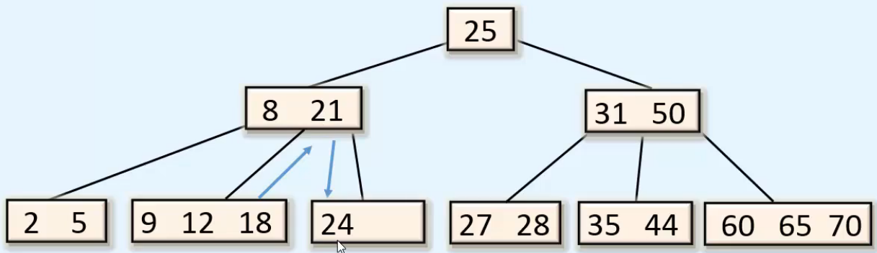

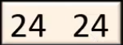 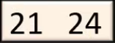

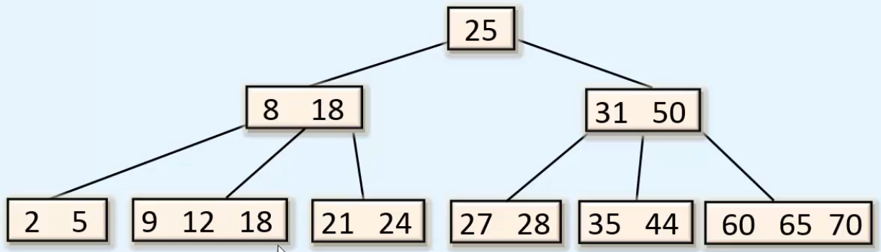  
* We decrement the numKey in the node where 18 was, which removes it.  
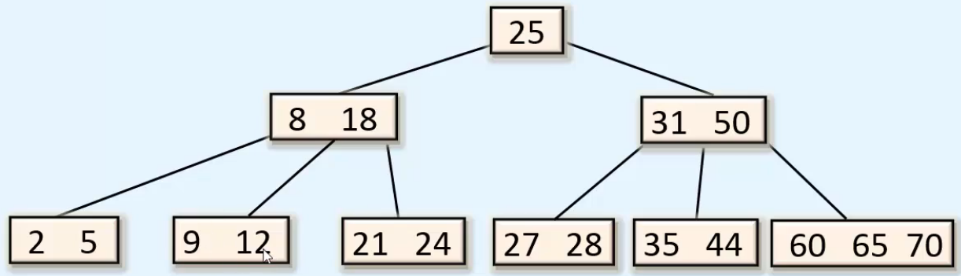

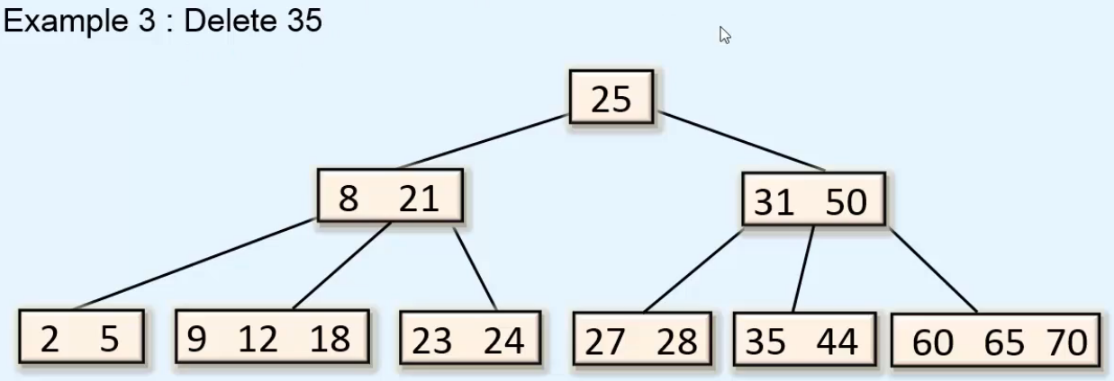  
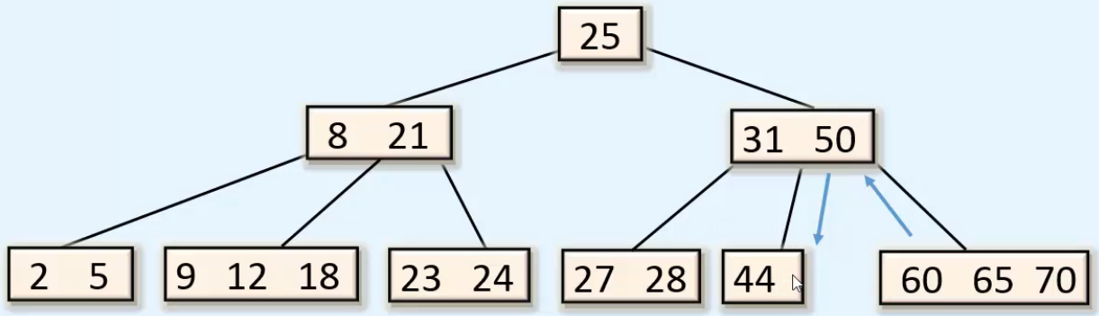  
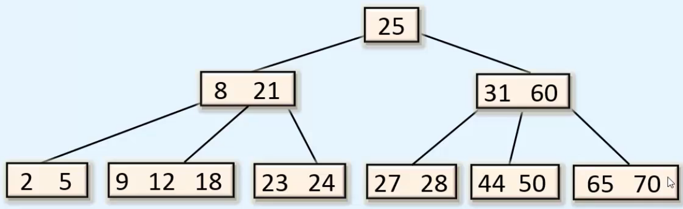

* **Both children have MIN numKeys**.  
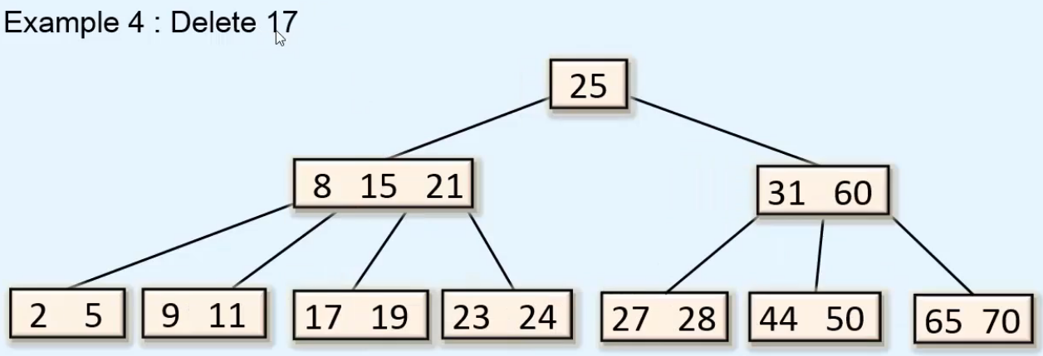  
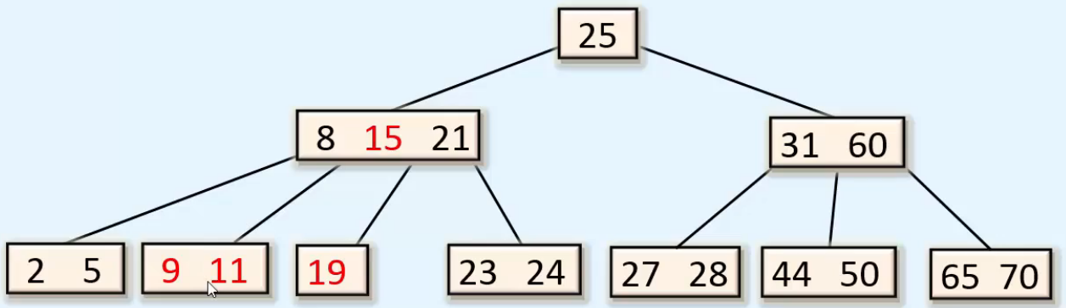  
=> **LEFT + Separator + Current combine into 1 Node**.  
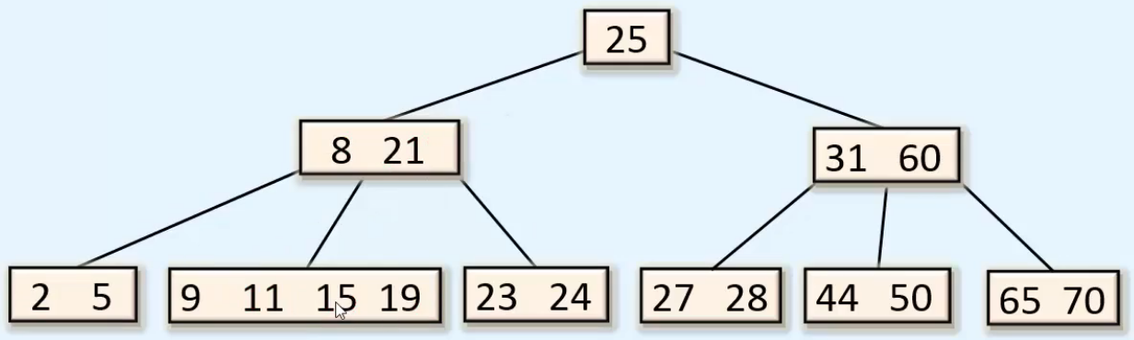  
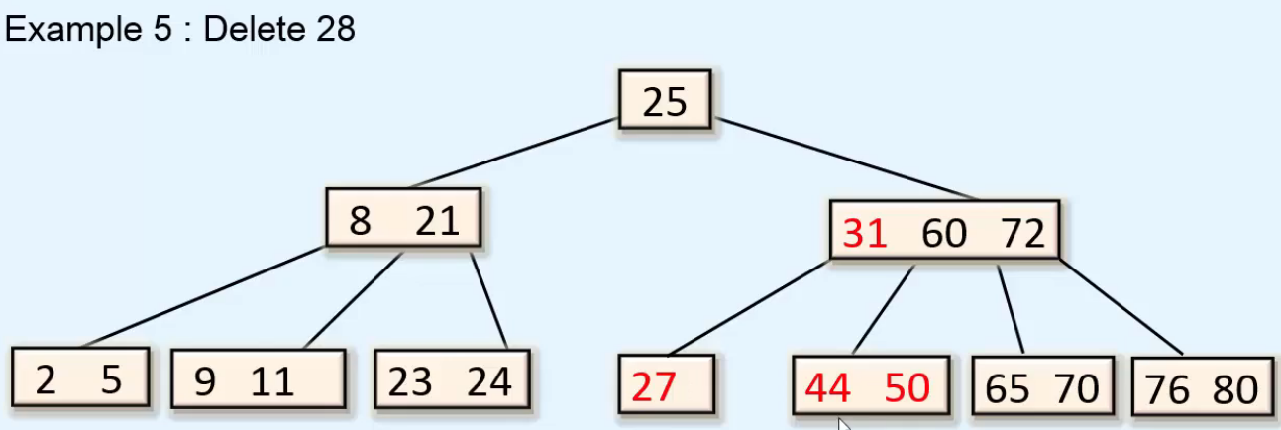  
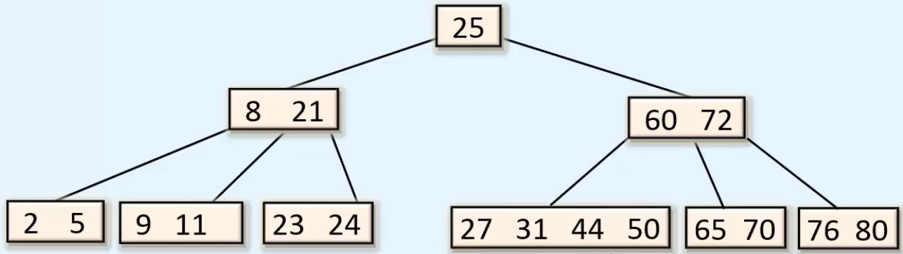

* **When the separator has MIN numKeys**.  
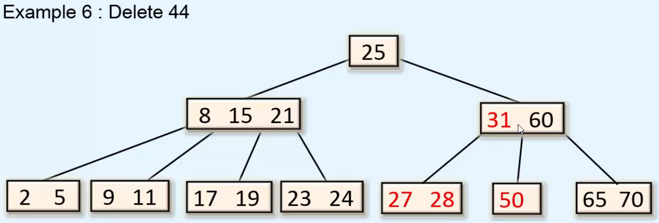

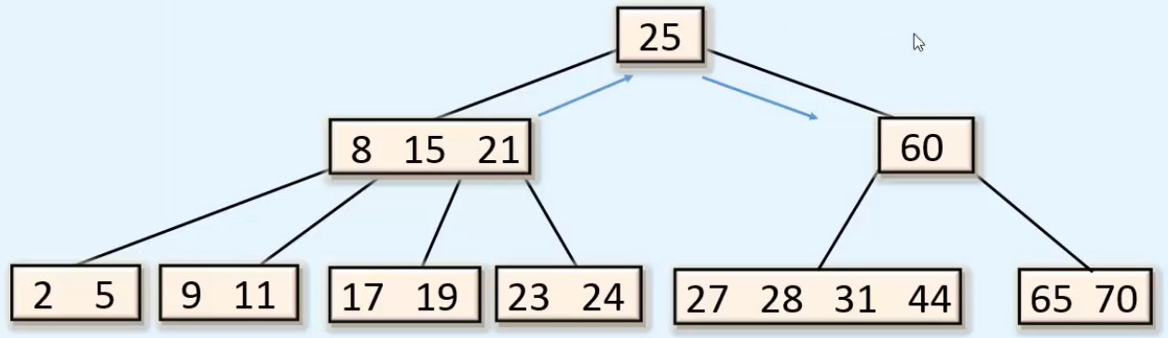  
* **We move 60 and the right child to the right**.  
* **Then we might the left child to the right**.  
* **Then we take 25 and place it before 60**.  
* **Then we take 21 and place it where 25 was**.  
* **Then the right child of 21 becomes the left child of 25**.   
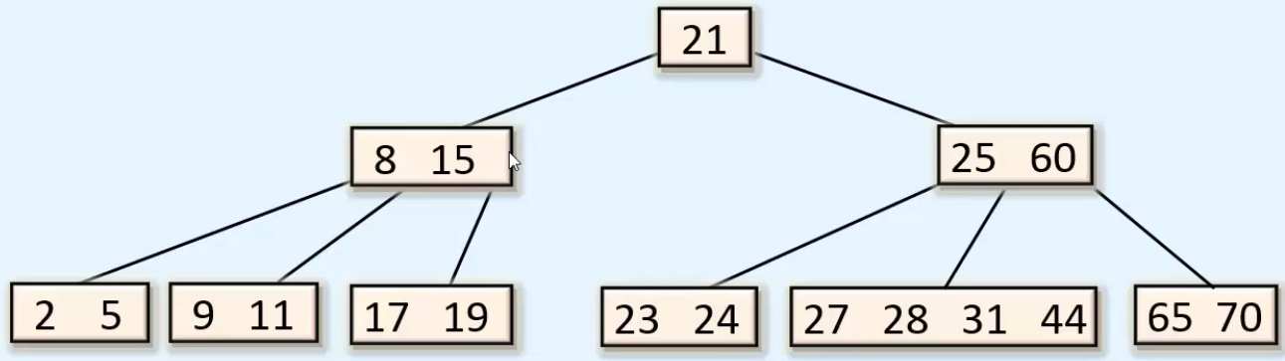

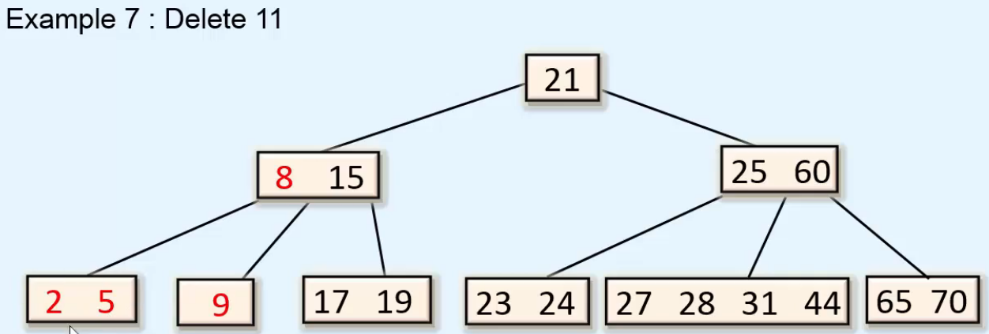  
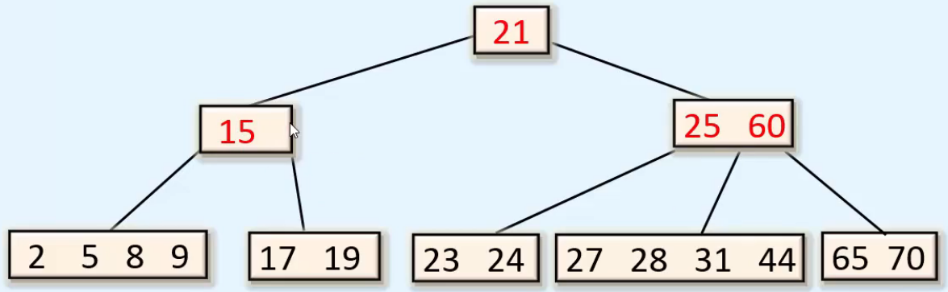  
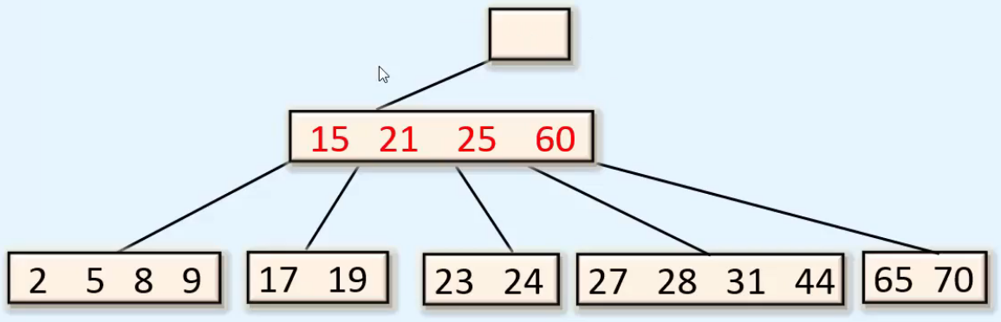  
* **We make this new combined node the root node**.  
* **Height of the tree decreases by 1**.  
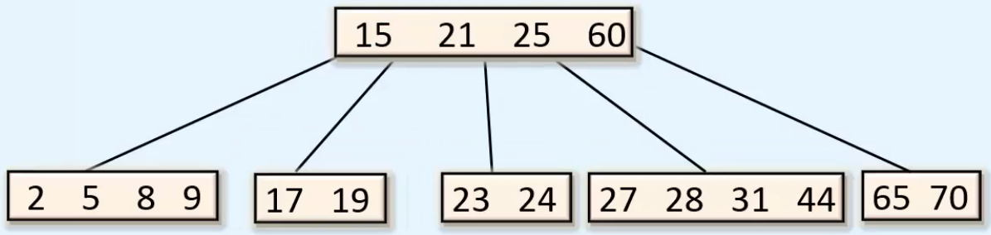

**Examples of Deletion from Non-Leaf Node**  
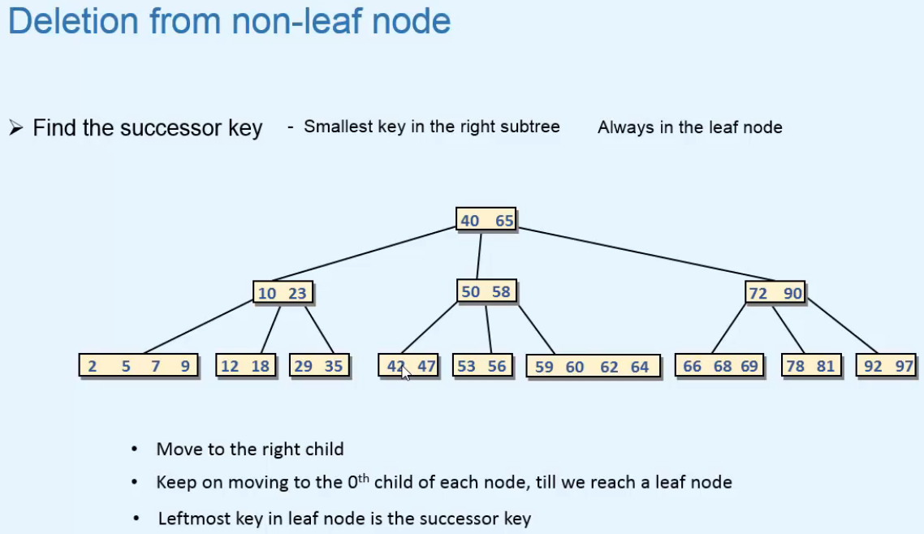  
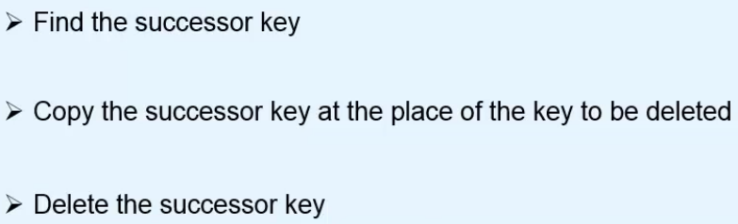=> **Successor is always in the Leaf Node and we’ve already seen how to delete those**.  
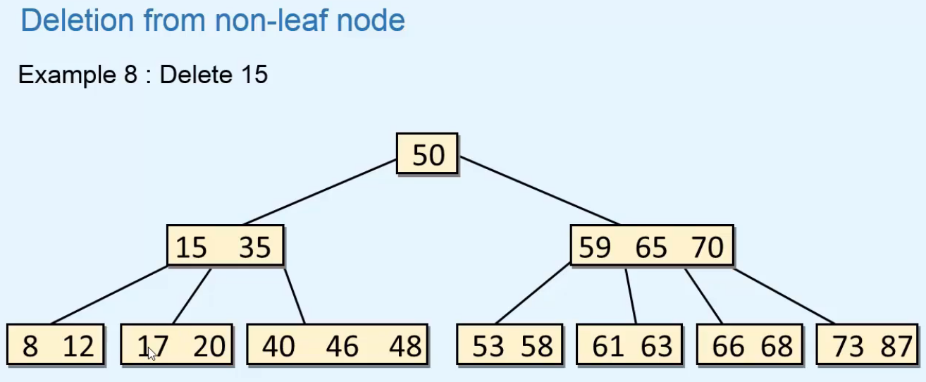  
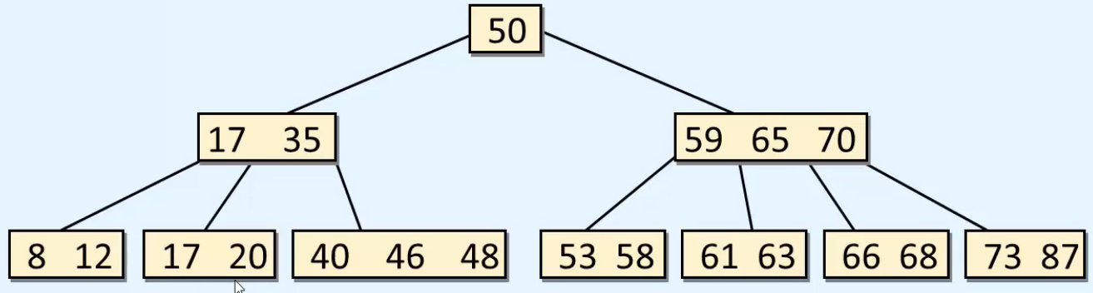  
=> **Now we delete 17 from a Leaf Node**.  
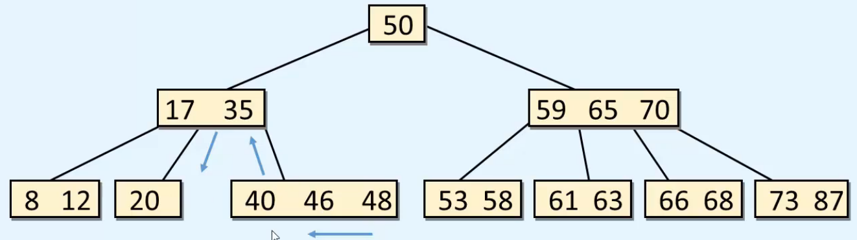  
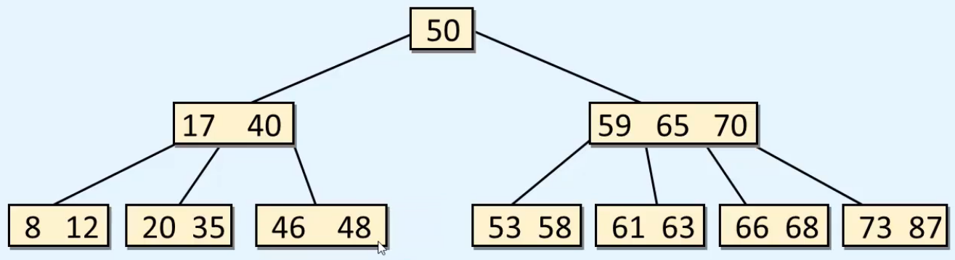

* **Another example**:  
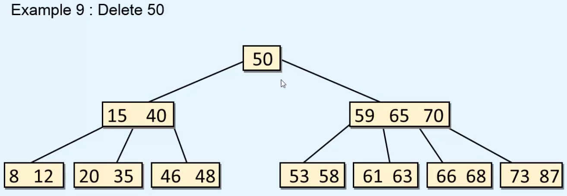  
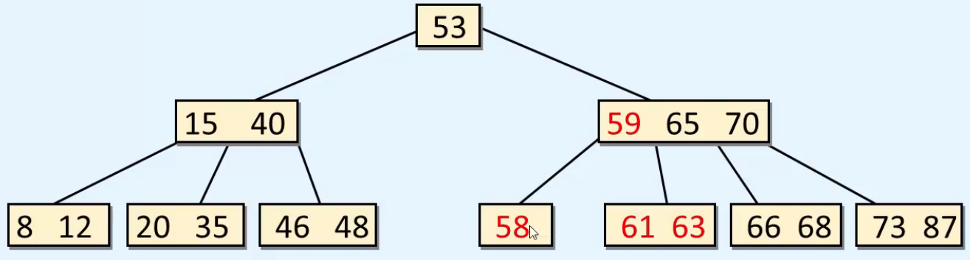  
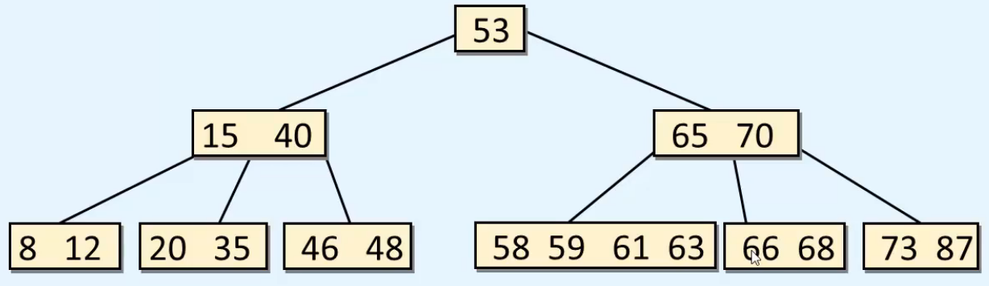

**Implementation of Deletion**  
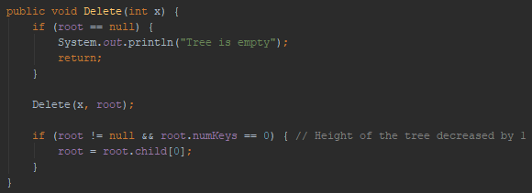  
* **For a non-leaf node we find the successor by moving to the nth child of p and then keep on moving down the tree 0th child till we reach a Leaf node and then the 1st key in the Leaf node is the Successor key and we copy it in place of the key that is to be deleted**.  
=> **And then we delete the successor key from the Leaf node**.  
* **s.key[1] is the successor**.  
* **p.child[n.value] is the root of the subtree in which the successor key is present**.

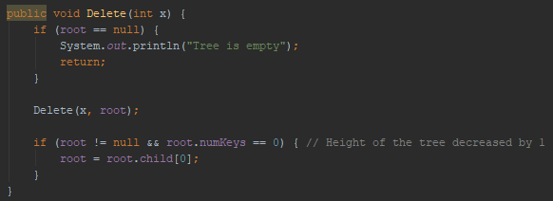  
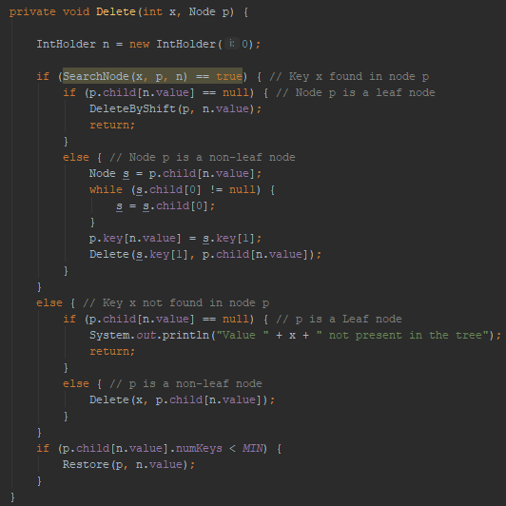  
* **The last IF with numKeys < MIN will be executed in the unwinding phase**.  
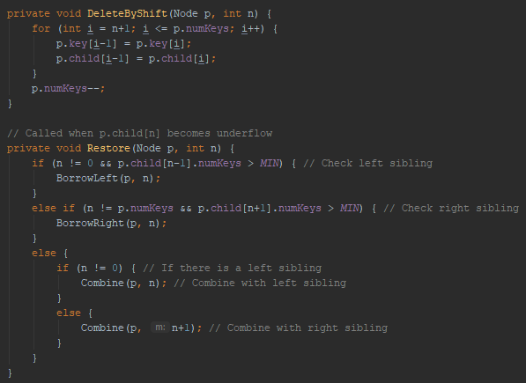  
* **p.child[n-1] is the left sibling**. **Here we check for n != 0 because if n == 0, then there’s no left sibling because n would be left-most child**.  
* **p.child[n+1] is the right sibling**. **Here we check for n != p.numKeys because if n == p.numKeys, there’s no right sibling because n would be right-most child**.

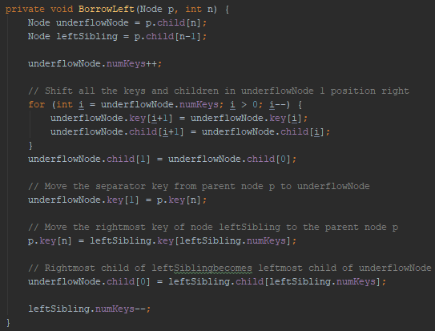  
* In BorrowLeft shifting - there’s no key at 0th position so to move the 0th child, we have to write the statement for it out of the loop.  
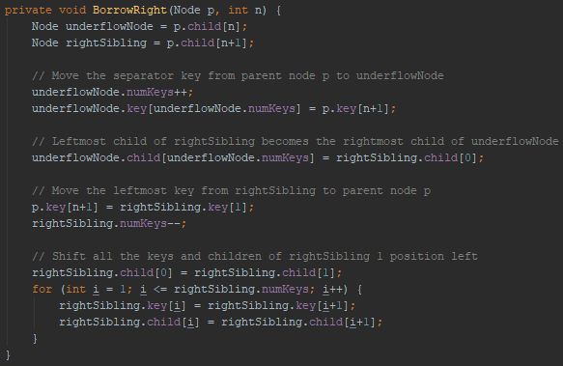  
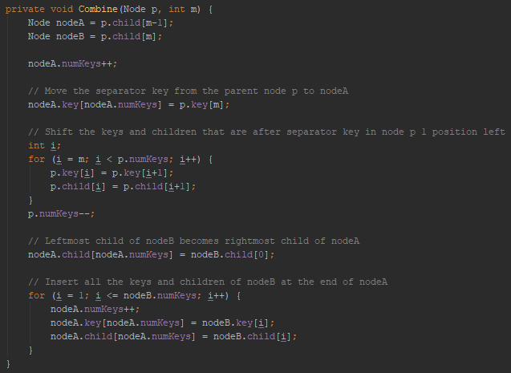  
* If we call:  
**Combine(p, n)** => **nodeB is the underflow node, nodeA is the LEFT sibling (n - 1, n)**  
**Combine(p, n+1)** => **nodeA is the underflow node, nodeB is the RIGHT sibling (n + 1 - 1 = n, n + 1)**  
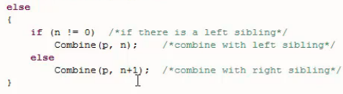  
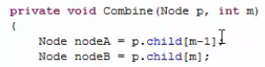  
=> So we can use 1 method - Combine() to combine with the LEFT or RIGHT sibling.